Teacher Name: Mark Casto / Amesbury High School

Goal / Objective: To give students an alternative to our school’s traditional senior research project by allowing them to participate in an authentic hands-on design challenge involving SolidWorks modeling and engineering research on concrete structural analysis.

District / School Environment (class size, grade level..etc):
Class Size: 5-10 students
Grade Level: 12th
Specifics: Students involved in student research.

Project Components:
This educational unit was developed to provide the teacher an easy-to-use, cost effective, engaging activity focused on real world scenarios. Through the use of an inquiry-based approach, students will be forced to pursue their own path of learning, while participating in a true hands-on experience. Students will be required to understand the basic material properties of concrete and the reinforcement placed within it to increase its load bearing capacity. Simple structural elements will be designed, built, and tested by students.

Introduction/Project Definition

This implementation plan will involve taking an existing lesson unit (concrete reinforcement) and extending it to include SolidWorks modeling. In terms of the traditional approach to the lesson it will be presented to senior students as a design challenge.

Team Membership (faculty, resources, community, partnerships)

Mark Casto – Director of Science
Brett Manoloff – Physics Teacher
Richard Peterson – Tech / Ed Teacher

Action Plan

The first step in instituting this project will be a recruit a set of students to test pilot this project. Students will meet to conduct the following:
Training on the basics of SolidWorks
- Part construction
- Assembly
- Load analysis
Design challenge (reinforcing a concrete beam to carry a 100lb load over a span of 2 feet:

- Concrete properties instruction
- Beam construction
- Loading and testing

Load analysis ( SW modeling vs. actual static testing)
- Redesign
- Feedback for future implementation

Student Deliverables (poster, PowerPoint…etc)

All Lesson Components (Including plans and assessments can be found at : www.collapse resistance.weebly.com

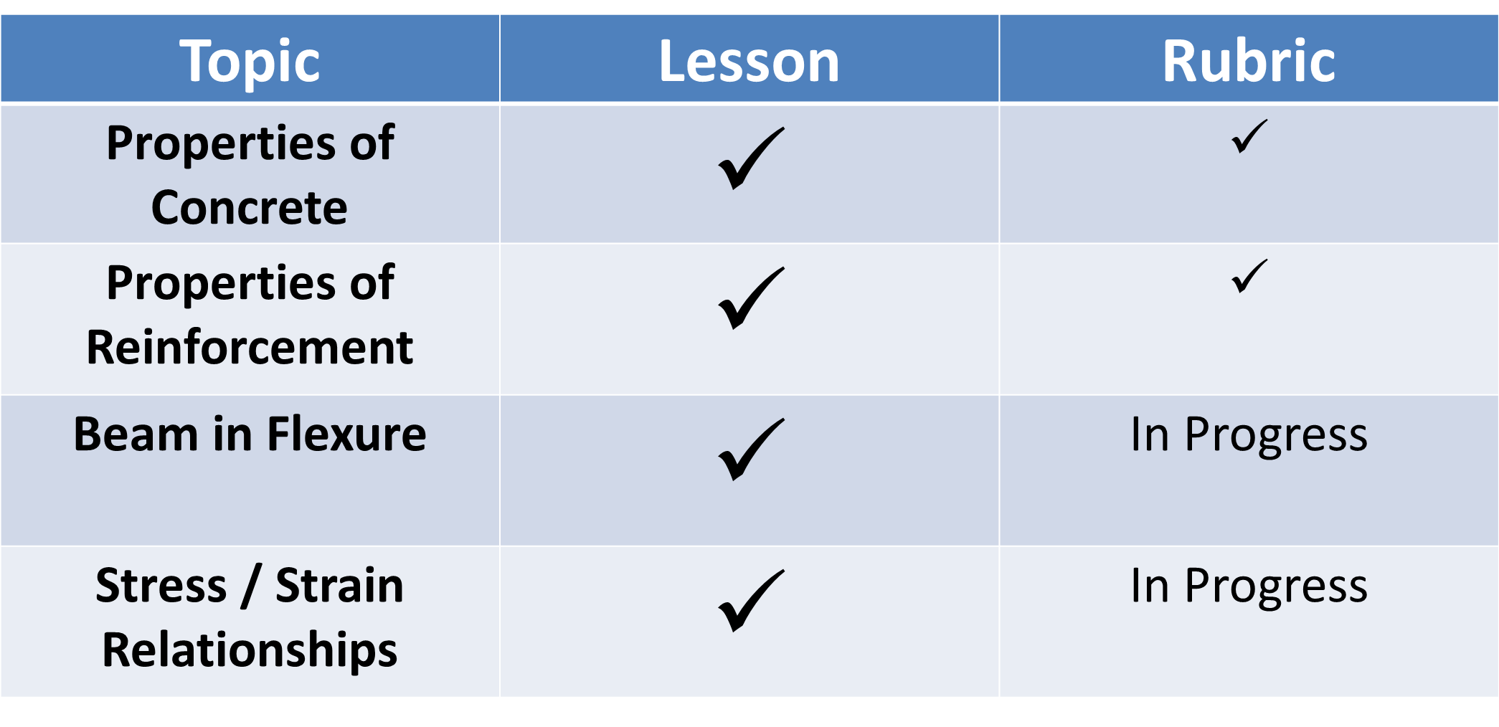

Teacher Deliverables

Overall Project Implementation Schedule

PROJECT IMPLEMENTATION ACTIONS PLANNED
TASK | COMPLETION DATE | COMMENTS
Develop project definition | 7/11 | Set at CAPSULE
Identify learning outcomes | 9/11 | With faculty
Develop key rubrics for project assessment points | 10/11 – 12/11 | With faculty
Develop team membership matrix | 9/11 | Meet with faculty involved beginning of year
Identify project sponsors | none
Develop presentation material | Spring 2012 | Before research projects due

Notes:

Student Outcomes/Content and Skills to be learned (Include connections to National, State, Local Benchmarks and Standards)

2.1 Identify and explain the engineering properties of materials used in structures (e.g., elasticity, plasticity, R value, density, strength).
2.2 Distinguish among tension, compression,
shear, and torsion, and explain how they relate to the selection of materials in structures.

Beyond Implementation

Will be determined after pilot program.

Implementation Impact:

Schedule (likely 3rd and 4th quarters of senior year)

Lab Considerations: none

Lab Availability: none

Performance Monitoring:

.

Appendix A: References

Appendix B: Student Handouts

See www.collapseresistance.weebly.com

